Section 1
General Information
A | School / Department: | School of Informatics
B | Brief description of the activity:  Start to finish, step by step | Experiments with human participants using TMS, stroboscopic light and psychometric scales.
C | Location(s) covered by this risk assessment:  Include building and room number if applicable | SCCS labs, Chichester 2
D | Equipment and materials used: | Computer, Monitor, Keyboard, Laptop, custom stroboscope: twelve 4500k J2 6V  white LEDs organised in a three-by-four grid with dimensions 128 x 176mm (width x height).  Transcranial Magnetic Stimulation (TMS) equipment from CE certified manufacturer MagStim rapid² TMS, x4 figure of 8 coils, TMS coil clamp, ear defenders.
E | Name(s) / Group(s) involved in the activity:  Consider Staff, Students, Visitors, Contractors and members of the public | David Schwartzman (Experimenter/Post Doc/Lab Manager), Anil Seth (Director, Sussex Centre for Consciousness Science, SCCS), Trevor Hewitt (PhD student), Danny Nacker (PhD student), Róisín Sharma (Undergraduate student) (ONLY under direct supervision and completion of Centre SOPs for safe use of EEG and Strobe). Other members of the SCCS (PhD students, postdocs, faculty) may use the lab after training and completion of Centre SOPs.
F | Name of person completing this risk assessment:  Students and PhD students should only complete risk assessments for their projects. Sign off for all student projects should be by the student’s supervisor. | Róisín Sharma | Signature |  | Date: | 04/07/2026
G | Risk assessment approved by:  The individual approving the risk assessment should be familiar with the work being undertaken. This should in most cases be the assessor’s supervisor, line manager or the principal investigator. | Anil Seth | Signature | 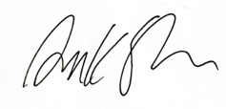 | Date: | 21/05/2026
H | Send a copy to School/Department Safety Coordinator

Section 2 Hazards & Controls
See the accompanying guidance document on the safety section website for further information on how to complete this form.
 |  | Risk with current control measures |  |  |  | Risk after additional control measures
Potential  hazards | Who might be harmed and how? | What current controls are in place to avoid harm? | Likelihood 1-5 | Severity 1-5 | Risk (L S) | What further control measures are required to reduce risk? | Likelihood 1-5 | Severity 1-5 | Risk (L S) | Who  will do this? | When must this be done? | Completed on:
Exposure to stroboscopic light | Individuals with light sensitivity to bright or stroboscopic light | As part of the Dreamachine project, specialists in sensitivities to stroboscopic light, including photosensitive epilepsy, were consulted. In collaboration with an extensive health and safety team and the event safety company Event Safety Shop, a comprehensive safety screening form was developed to mitigate risks associated with stroboscopic exposure. Participants who do not pass this screening will be excluded. The effectiveness of this procedure is demonstrated by the nearly 40,000 individuals who safely participated in Dreamachine. Prior to the experiment, participants will complete the Sussex Strobe Safety Screening Questionnaire (4SQ), which assesses risk factors, such as history of negative experiences from flashing light, migraines, psychiatric factors, substance use and recent sleep; as well as study-specific eligibility including neurological and mental health and sensory sensitivity.  During the experiment, participants will be continuously monitored for any signs of adverse reactions to the stroboscopic stimulation.  In a review of adverse responses to SLS (Schwartzman et al, 2025), estimated prevalence corresponded to the low end of MRI terminations in screened adults due to anxiety or claustrophobia. Incidents included anxiety, eye discomfort, dizziness and headaches. The experimenter will pay special attention to these factors. The experimenter will have access to an emergency stop button to immediately terminate the stimulation if necessary. Participants will also be instructed that they can stop the experience at any time by covering their eyes, at which point the experiment will cease.  Photobiological safety will be maintained by ensuring that stroboscopic stimulation is measured at the participant position using a calibrated light meter, with exposure duration, eye state, distance and stimulation parameters documented, and with compliance assessed against Directive 2006/25/EC/IEC 62471 where applicable.  The experimenter is first-aid trained and will protect the participant and contact emergency services according to the protocols outlined by St John’s ambulance. In the case of any adverse reaction, the experimenter will stop the flickering light immediately using the emergency ‘stop’ button on the device. The experimenter will encourage the participant to stay in the lab to be monitored for an hour. Rationale for this will be fully explained and the experimenter will recommend the participant follows up this incident with a medical professional. If anything is highlighted, emergency services will be called. If no further symptoms are apparent after an hour, the participant may leave. Any incidents will be recorded and reported to the lab manager. | 1 | 4 | 4 (L) | Participants may experience unexpected discomfort from the strobe. Before taking part in the full strobe sessions, participants will experience a 10 second trial of the light. They will then be asked how they feel, and the sessions will only commence with their permission. The participant will be reminded of their right to withdraw at any time, without needing to provide an explanation. Following each strobe session, the participant may temporarily feel disorientated, have eye strain and experience after-images from the light. They may take as much time as is needed to re-adjust before continuing with questionnaires and the interview. Participants will be offered water or fresh air as needed. Throughout the experiment, the experimenter will assess signs of discomfort and will terminate the experiment if they feel the participant is at risk.  This experiment contains three dynamic strobe sessions that will vary in frequency and rhythmicity, which should reduce monotony of the strobe experience. Participants will be offered a break between each session, to reduce fatigue. | 1 | 2 | 3 (L) | The experimenter running the trial, including the PI (Roisin Sharma) and project supervisor (David Schwartzman) | After a full training and a detailed assessment of risk mitigation strategies, pilots will be run to refine the experiment, following feedback.
TMS use in experimental context | People with sensitivities to brain stimulation by TMS | Our safety screening ensures no one at higher risk due to seizures, migraines, head implants, neurological health, medication, tinnitus or pregnancy will take part, in accordance with these established guidelines (Rossi et al., 2021).  Specifically, screening procedures will follow: Safety, ethical considerations, and application guidelines for the use of transcranial magnetic stimulation in clinical practice and research.  A Standard Operating Procedure (SOP) has been developed outlining safety mitigation strategies and detailing the protocol to be followed in the unlikely event of an adverse reaction.  During the procedure, stimulation intensity will never exceed 80% and it will be confirmed in the prescreening that no participants are on medication that lowers seizure threshold (as a precaution despite Rossi et al. (2021) no longer deeming this compulsory for exclusion.  The experimenter will maintain constant communication with the participant to monitor for adverse side effects and allow the participant to indicate their level of comfort or ask questions. This includes post-stimulation.  In the case of any adverse reaction in a participant that seems fit and well, the experimenter will encourage the participant to stay in the lab to be monitored for an hour. If anything is highlighted, emergency services will be called. If no further symptoms are apparent after an hour, the participant may leave.  In order to conduct a TMS experiment within the SCCS lab, the experimenter is required to provide proof of current first aid responder training, and will undergo supervised training to conduct TMS. They will only commence pilot trials after their capacity to adhere to the SOP protocols and sufficient theoretical understanding has been approved by the lab manager (Dr David Schwartzman). | 1 | 4 | 4 (L) | The TMS safety prescreening will be re-complete on arrive for the experiment and will check for situational factors known to increase seizure risk, such as sleep deprivation.  The TMS session  will take place in a dimly lit room. Before the session, the participant will be guided through the setup, shown how the coils work, and the procedure will be fully explained to alleviate any concerns. Once the participant is in a comfortable position on the chair, the lights will be dimmed, and the participant will begin a resting state of 5 minutes to acclimatise to the darkness before the session commences.  Participants may experience mild scalp or neck muscle contractions which can trigger a headache. We will optimise coil orientation and intensity to limit discomfort, prompt participants to report any unpleasant sensations at each stage and stop the session immediately if significant discomfort arises. Following identification of the phosphene threshold, the participant will complete the TMS Adverse Events and Associated Sensation Questionnaire (TMSens-Q; Giustiniani et al, 2022), which will monitor side effects and any adverse effects.  As well as maintaining constant communication with the participant, the experimenter will remain vigilant to technical difficulties, including but not limited to unexpected reactions and human factors.  The participant will be positioned on a reclined Magstim TMS chair on a neck rest with the head exposed in an upright position. The lack of head support may become uncomfortable; therefore, the participant will be informed that they can take a break and re-adjust themselves between trials as needed.  Participants will be required to wear a lycra cap. On fitting, the experimenter will ensure it doesn’t feel too tight on hair and different sizes will be available to ensure a comfortable fit. This will be specified in the information sheet, and the experimenter will check for allergies to the material prior to fitting.  Some evidence suggests the transient acoustic artefact produced by the deforming TMS coil are above the noise exposure limits for impulsive noises (Rossi et al, 2021). Both the participant and experimenter will be provided with ear defenders. Compared to ear plugs, this will standardise the effectiveness of noise protection across trials.  According to Rossi et al (2021), TMS-induced cognitive effects tend to be low when present. As a figure-of-eight coil will be used to increase precision of stimulation, the experience of the phosphene is expected to be transient and we do not anticipate further post-stimulation effects. Between each stimulation increment, the participant will be offered a break for as long as it takes for them to be prepared to continue the session and will be welcome to discuss their experience with the experimenter, who will be calm, friendly and develop rapport throughout. | 1 | 2 | 3 (L) | The experimenter running the trial, including the PI (Roisin Sharma) and project supervisor (David Schwartzman) | After a full training and a detailed assessment of risk mitigation strategies, pilots will be run to refine the experiment, following feedback.
Combined risk of TMS and SLS | Individuals who experience carry-over effects from TMS/SLS | The prescreening excludes high-risk participants according to contraindications of TMS and SLS as outlined in the SOP for each of these procedures individually. Seizures have been reported as adverse side effects for both SLS and TMS, therefore this combination may increase risk if either procedure has after-effects that persist after the stimulation procedures, particularly since both methods of stimulation increase activity in the occipital lobe. However, evidence suggests cognitive and neurological effects for TMS and SLS are transient.  Safety precautions for TMS and SLS include continuous observation from the first aid trained experimenter during and following the stimulation procedures; the opportunity for rest breaks of durations determined by the participant; self-report via the TMSens-Q (Giustiniani et al, 2022) and verbal confirmation of an unaltered state of physical and mental wellbeing following the sessions.  Regarding seizures, a review on TMS safety did not find any evidence for kindling effects (Rossi et al, 2021). Side effects from TMS tended to be reported during or immediately after stimulation: Psychiatric adverse effects induced by rTMS were transient, with a rapid spontaneous resolution after TMS cessation.  Following both the TMS and SLS procedure, the participant will remain seated as they complete questionnaires. During this time, the experimenter will observe the wellbeing of the participant and will monitor prolonged effects by assessing their results from the TMSens-Q and asking them how they feel. Participants will be instructed to only get up once they are certain they feel ready and have returned to the state of physical and mental wellbeing they began the session with, and to let the experimenter know if this is not the case. | 1 | 4 | 4 (L) | None
Electric Shock from portable appliances | Lab users | All laboratory equipment should be CE certified. At least operatives must visually inspect the equipment before its use, when appropriate equipment would have been PAT Tested. | 1 | 3 | 3 (L) | None
Slip and Trip Hazards | Lab users | All cables will be hidden behind furniture. Where this is not possible, any cables required to transverse walkways or steps will be taped down with hazard tape. | 1 | 2 | 2 (L) | None
Fire | Burns, loss of consciousness and major losses. All staff members, visitors | Students and staff must adhere to established emergency procedures. In the event of a fire, individuals must raise the alarm, alert others, and evacuate the building immediately. Personal belongings must not be retrieved, and no attempts should be made to extinguish the fire using fire extinguishers. | 2 | 5 | 10 (M) | Briefing on means of escape and assembly point locations will be provided to students and their supervisors during induction. Participants will also receive instruction on fire exit locations. Participants will not be left unsupervised and will remain accompanied at all times by a member of staff trained in fire emergency procedures. | 2 | 2 | 4 (L) | Lab users | During induction
Continue additional pages if required

Section 3 Risk Matrix
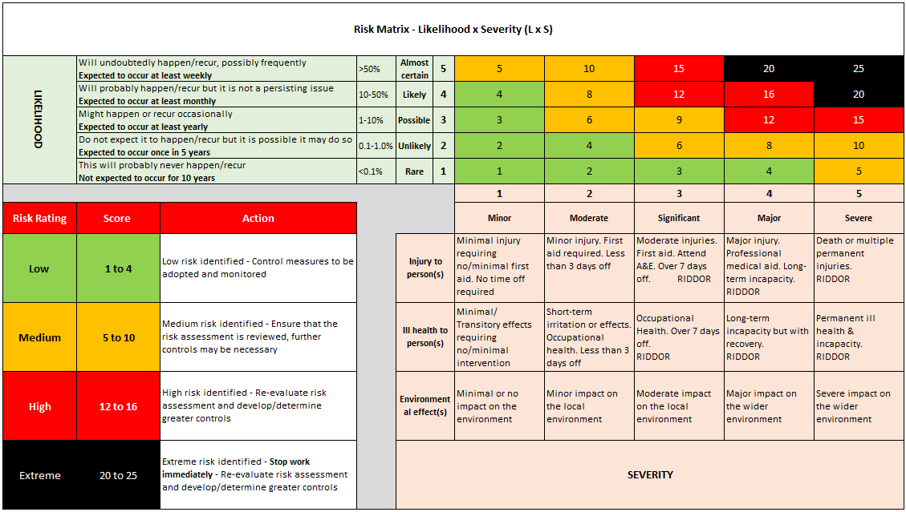
Section 4 Communication of Risk Assessment to Users

This assessment can either be communicated to groups or Individuals as part of a School or Divisional process or signed off by individual users.

School or Divisional Process
The contents of this risk assessment will be communicated to lab users in the University training programmes.

Sign off by users
All individuals carrying out activities covered under this risk assessment should sign below after reading it.
By signing this document you confirm that; you have read and understood this risk assessment and that it is an accurate representation of work practice
Name | Signature | Date | Name | Signature | Date
Róisín Sharma |  | 26/03/2026
David J Schwartzman | 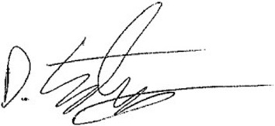 | 07/05/26

Section 5 Record of Risk Assessment reviews
Risk assessments should be reviewed every three years or earlier if there is a significant change in the process or after an incident/near miss
Date of review: |  | Reviewed by: |  | Comments / date of next review:
Date of review: |  | Reviewed by: |  | Comments / date of next review:
Date of review: |  | Reviewed by: |  | Comments / date of next review:

